Unit 2: Understanding Programming in Engineering | ENCO101

Module Description

This module is intended to familiarise the students with the knowledge they require to develop competency and skills in the use of computing concepts required for the purposes of design, development and application within engineering settings.

Unit Description
This unit introduces students to the fundamental principles of programming in the context of engineering. It focuses on how programming is applied to solve engineering problems and automate processes, enhancing efficiency and precision. Students will learn to develop algorithms and apply programming concepts using popular programming languages relevant to engineering tasks. The unit emphasises problem-solving skills, logical thinking, and the integration of programming into engineering design, simulation, and analysis.

1. Preferred User and Communication Interfaces

A user interface (UI) is the point of interaction between a user and a computer system or its software application. It encompasses everything that allows a user to interact with the computer. There are several types of user interfaces. We will only focus on the preferred ones, namely:
- Graphical User interface (GUI)
- Command Line Interface (CLI)
- Voice User Interface (VUI)
- Touch User Interface (TUI)
- Augmented Reality (AR) and Virtual Reality (VR) interfaces
- Gesture-Based Interfaces

1.1 Communication Interfaces
Communication interfaces consists of the following:
- Graphical user interface
- Text-based communication
- Video communication
- Social media platforms
- Collaboration platforms
- IoT (internet of things) interfaces

Preferences for the interfaces depend on the individual’s user habits, the nature of the task, etc..

1.2 The 7-layer OSI and 5-layer TCP-IP Computer Network Model
The 7-layer OSI and 5-layer TCP-IP computer network models are quite complex to understand. OSI is the acronym for Open Systems Interconnection model, TCP/IP is the acronym for Transmission Control Protocol/Internet protocol. These are conceptual frameworks that standardise the telecommunication or computing system in multiple layers. Each layer has a specific responsibility. Together, they allow communication between devices over a network.

The 7-layer OSI are:
- Layer 1: Physical Layer: This layer is concerned with the physical connection between devices and focuses on the transmission and reception of raw data to the actual device.
- Layer 2: Data Link: Responsible for creating a reliable link between the two connected nodes.
- Layer 3: Network Layer: The network layer manages logical addressing and routing data between different networks.
- Layer 4: Transport Layer: This layer ensures end-to-end communications, error recovery and flow control.
- Layer 5: Session Layer: The session layer manages the connections between applications of different devices.
- Layer 6: Presentation Layer: This layer deals with syntax and the semantics of information exchanged between systems.
- Layer 7: Application Layer: The application layer provides the network service to the end user.

The 5-layer TCP/IP Model are:
- Link layer or Network Interface layer
- Internet layer
- Transport layer
- Application layer
- Host-to-network layer

1.3 Programming Language and the Representation of Data
Programming is a diverse tool for anyone in the field of science and technology. Programming allows programmers to communicate instructions to a computer. These instructions specify how the computer should represent and manipulate the data for use. Programming can be used to represent data in a way that allows us to manipulate it to achieve a specific outcome, to control the flow of data and restrict what should and should not be done; and to apply algorithms and manage the storage of the data gathered.

The MATLAB is a suitable program for first-time programmers. It helps you understand the logical sequencing used in coding programmes, thus the similarities between Python and MATLAB.

Take NOTE!
MATLAB uses the same principles and functions that Python is built on.

1.4 The MATLAB Environment

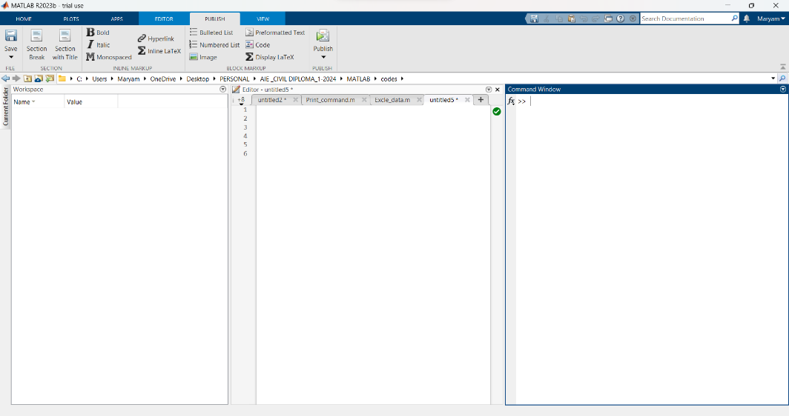
Figure 2-1: The MATLAB Environment

The Workspace
This space shows the characteristics of the data that is expressed in the editor window. The workspace indicates the:
- Size of data bits
- Size of arrays
- Values in the commands window.

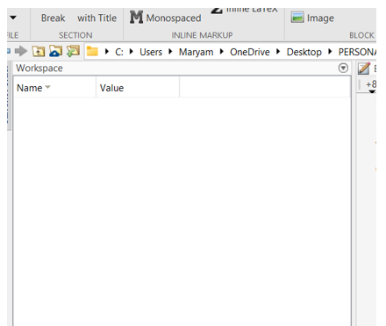
Figure 2-2: Workspace Window

The Editor Window
The editor window is the window that is used the most. This is the window where the scripts are programmed and saved from.

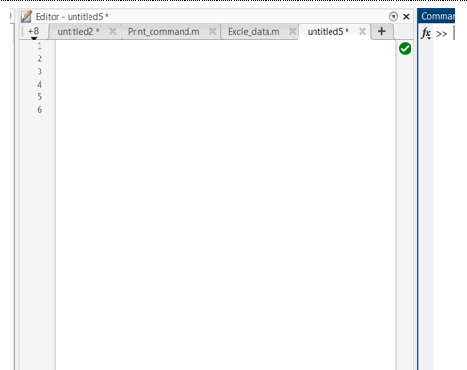
Figure 2-3: Editor Window

The Command Window
This window is the output window. All data processed is shown here.

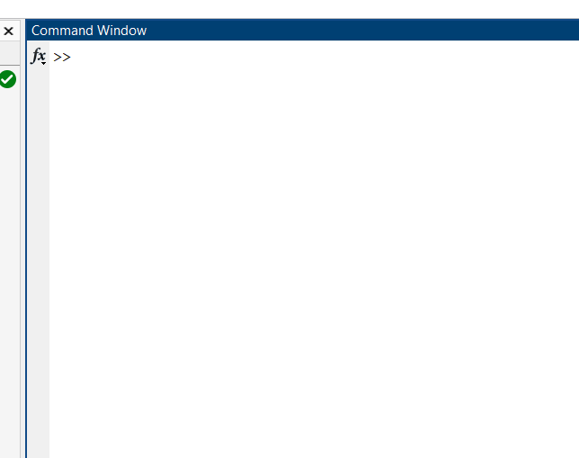
Figure 2-4: Command Window

The Figure Window
This window displays all the plotted figures created in the Editor window.
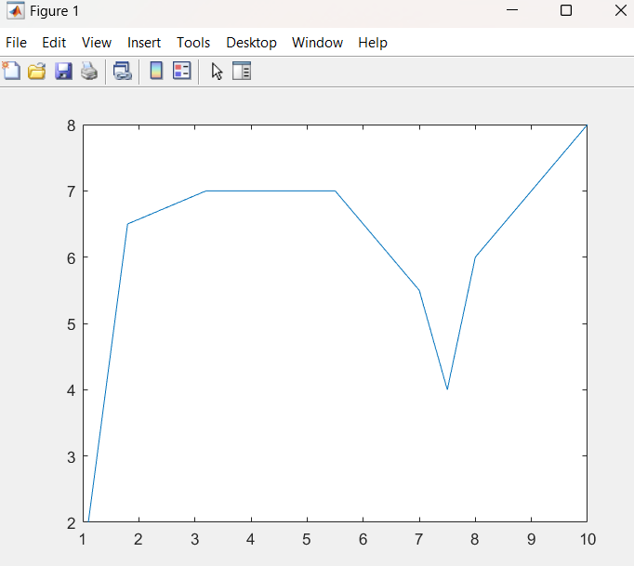
Figure 2-5: Figure Window

1.5 The Layout of this Textbook, Syntax and Useful Tips
Double percentage symbols (%%) before any expression or text in the Editor, instructs MATLAB that that entire row is extra information. It is written specifically so that the code could be better understood. It also instructs MATLAB that the instruction or text after the ‘%%’ symbol should not be run. The text will then be highlighted in green in the editor window after the ‘%%’, in comparison to the standard black text (unless chosen otherwise).

The constant running of code or programs when typing in the Editor window, can take up a lot of memory and space. It can also be time-consuming to scroll down and see if your program has been executed successfully. In this lecture note, you will constantly see the following code at the beginning of each text: Clc; close all; clear

The details of this code is explained further below. In layman’s terms, it clears the Command window each time a code is run. This makes understanding your results much easier.

You might create an infinite loop in your editor window where the code never stops running. To end the code in the command window without exiting the entire software, you can press ‘Ctrl+C’. The code exits and you can fix your code.

Layout
This study guide is laid out a manner that makes it user friendly for first year engineering students. When tutorial or examples are executed in MATLAB software, the code is displaced as below in the Code Format box. The Editor window commands will be highlighted in grey, while the output in the Command window will show the ‘>>’ symbol before it.

If there is code that needs to be executed, it is written in between explanations or text and the study guide converts that inline code to a similar font seen MATLAB and the code window below. When a set of instructions are preceded by the ‘%%’ symbol, and the code is published, it turns into an orange block font as seen below.

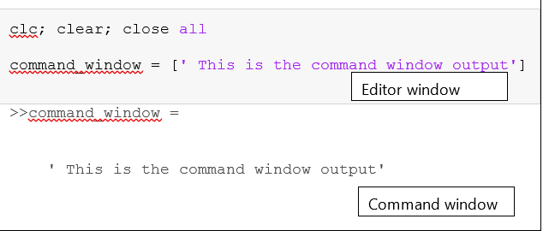
Figure 2-3: The Code Format in the Editor Window

2. Mathematical Operations with Matrices

Matrices are powerful operators. They can contain multiplied data about certain mathematic formulas, etc. We can put tables of data and graphs in matrices. What would be the point if we can’t use that data for our benefit?

It is assumed that when this subject commences, there is no pre-existing knowledge of linear algebra and matrices. So, firstly the principles of linear algebra will be covered in each section, and then detailed examples of how these principles can be used will be covered in detail afterwards.

2.1Addition and Subtraction
The rules for addition and subtraction of elements in matrices follow the same rules. The matching columns and rows can only be added or subtracted. Let's look below:

A = $\left[\begin{aligned}\begin{matrix}A_{11} & A_{12} & A_{13} \\ A_{21} & A_{22} & A_{23} \\ A_{31} & A_{32} & A_{33}\end{matrix} \\ \end{aligned}\right]$ and B = $\left[\begin{matrix}B_{11} & B_{12} & B_{13} \\ B_{21} & B_{22} & B_{23} ] \\ B_{31} & B_{32} & B_{33}\end{matrix} \right]$,

Then the matrices can be added:

C = $\left[\begin{matrix}{(A}_{\begin{aligned}11 \\ \end{aligned}}+B_{11}) & {(A}_{\begin{aligned}12 \\ \end{aligned}}+B_{12}) & {(A}_{\begin{aligned}13 \\ \end{aligned}}+B_{14 }) \\ {(A}_{\begin{aligned}21 \\ \end{aligned}}+B_{21}) & {(A}_{\begin{aligned}22 \\ \end{aligned}}+B_{22}) & {(A}_{\begin{aligned}23 \\ \end{aligned}}+B_{23 }) \\ {(A}_{31}+B_{31}) & {(A}_{\begin{aligned}32 \\ \end{aligned}}+B_{32}) & {(A}_{\begin{aligned}33 \\ \end{aligned}}+B_{33})\end{matrix}\right]$

clc, clear all

A = [1 4 6 ; 4 5 6 ; 3 4 4 ]
B = [ 3 3 4 ; 5 6 4 ; 1 0 0 ]
C = A + B

>> A = 1 4 6
4 5 6
3 4 4
>> B = 3 3 4
5 6 4
1 0 0
>> C = 4 7 10
9 11 10
4 4 4

2.2 Multiplication
The rules for multiplying arrays and matrices are slightly different. The elements in the first row of A is multiplied by the corresponding elements in the first column. The products of the two matrices now have a new dimension.

If it was a 4x3 multiplied by a 3 x 2 matrix, it would end up being a 4 x 2 matrix.

D = $\left[\begin{aligned}\begin{matrix}A_{11} & A_{12} & A_{13} \\ A_{21} & A_{22} & A_{23} \\ A_{31} & A_{32} & A_{33} \\ A_{41} & A_{42} & A_{43}\end{matrix} \\ \end{aligned}\right]$ and E = $\left[\begin{matrix}B_{11} & B_{12} \\ B_{21} & B_{22} \\ B_{31} & B_{32}\end{matrix} \right]$,

F = $\left[\begin{matrix}{(A}_{\begin{aligned}11 \\ \end{aligned}}B_{11}{+ A}_{\begin{aligned}12 \\ \end{aligned}}B_{21 }{+ A}_{\begin{aligned}13 \\ \end{aligned}}B_{31}) & {(A}_{\begin{aligned}11 \\ \end{aligned}}B_{12}{+ A}_{\begin{aligned}12 \\ \end{aligned}}B_{22 }{+ A}_{\begin{aligned}13 \\ \end{aligned}}B_{32}) \\ {(A}_{\begin{aligned}21 \\ \end{aligned}}B_{11}{+ A}_{\begin{aligned}22 \\ \end{aligned}}B_{21 }{+ A}_{\begin{aligned}23 \\ \end{aligned}}B_{31}) & {(A}_{\begin{aligned}21 \\ \end{aligned}}B_{12}{+ A}_{\begin{aligned}22 \\ \end{aligned}}B_{22 }{+ A}_{\begin{aligned}23 \\ \end{aligned}}B_{32}) \\ {(A}_{\begin{aligned}31 \\ \end{aligned}}B_{11}{+ A}_{\begin{aligned}32 \\ \end{aligned}}B_{21 }{+ A}_{\begin{aligned}33 \\ \end{aligned}}B_{31}) & {(A}_{\begin{aligned}31 \\ \end{aligned}}B_{12}{+ A}_{\begin{aligned}32 \\ \end{aligned}}B_{22 }{+ A}_{\begin{aligned}33 \\ \end{aligned}}B_{32}) \\ {(A}_{\begin{aligned}41 \\ \end{aligned}}B_{11}{+ A}_{\begin{aligned}42 \\ \end{aligned}}B_{21 }{+ A}_{\begin{aligned}43 \\ \end{aligned}}B_{31}) & {(A}_{\begin{aligned}41 \\ \end{aligned}}B_{12}{+ A}_{\begin{aligned}42 \\ \end{aligned}}B_{22 }{+ A}_{\begin{aligned}43 \\ \end{aligned}}B_{32})\end{matrix}\right]$

D = [ 3 4 6 ; 6 7 8 ; 7 8 8 ; 0 9 6]
E = [ 2 3; 4 6 ; 5 6]

F = D * E

>> D = 3 4 6
6 7 8
7 8 8
0 9 6
>> E = 2 3
4 6
5 6
>> F = 52 69
80 108
86 117
66 90

2.3 Division
This topic is slightly more complex, and the rules can be found in linear algebra textbooks. Division won’t be covered in the notes but will be covered in the class work as extra information.

2.4 Elemental Operations
Linear algebra has other mathematical operations based on element-by-element relationships. Linear algebra defines the difference between multiplication and ‘dot’ product, represented by the ‘dot’. Dot product requires matrices of the same size. The product of elements is not added as in the matrix multiplication. The same rules applied for division and powers. Up until now, not many sample problems were used where we combine all the lessons learnt. Let's use the sample example from the textbook.


READ Additional Resources

Refer to the following resource in the Student Portal.
Read: Prescribed Textbook: Gilat, A. (2012). MATLAB: An Introduction with Applications (6th ed.). Wiley. page 83 – Sample problems 3-4.

In the circuit below we want to determine the current in each resistor using the mesh current method. This method (which is covered in Electrical Engineering introductory modules) is based on Kirchhoff’s voltage law.

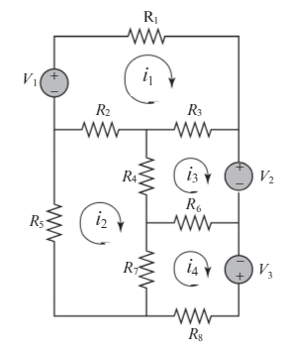
Figure 5-1: Circuit

 | 1 | 2 | 3 | 4 | 5 | 6 | 7 | 8
Voltage (V) | 20 | 12 | 40 | / | / | / | / | /
Resistance (Ω ) | 18 | 10 | 16 | 6 | 15 | 8 | 12 | 14
Table 5-1: Values for Resistance and Voltage
How would we find the currents using the mesh method? The Law states that ‘the sum of the voltage around the close circuit is zero.’ In this method, a current is first assigned for each mesh. The law is then applied to each mesh. This then results in a system of linear equations. The current in a resistor that belongs to two meshes is the sum of the current in the same directions (clockwise here).

The voltage is positive if the current flows to the negative pole and vice versa.

When we write it in linear equations, it looks like the following:
V_1- R_1 i_1- R_3 (i_1-i_3 )-R_2 (i_1-i_2 )=0
- R_5 i_2- R_2 (i_2-i_1 )-R_4 (i_2-i_3 )-R_7 (i_2-i_4 )=0
-V_2- R_6 (i_3-i_4 )-R_4 (i_3-i_2 )-R_3 (i_3-i_1 )=0
V_3- R_8 i_4- R_7 (i_4-i_2 )-R_6 (i_4-i_3 )=0

How does it look in a normal matrix?

$\left[\begin{matrix}-(R_{1}+R_{2}+R_{3}) & R_{2} & R_{3} & 0 \\ R_{1} & -(R_{2}+R_{4}+R_{5}+R_{7}) & R_{4} & R_{7} \\ R_{1} & R_{4} & -(R_{3}+R_{4}+R_{6}) & R_{6} \\ 0 & R_{7} & R_{6} & -(R_{6}+R_{7}+R_{8})\end{matrix}\right]\left[\begin{matrix}i_{1} \\ i_{2} \\ i_{3} \\ i_{4}\end{matrix}\right]$ = $\left[\begin{matrix}{-V}_{1} \\ 0 \\ V_{2} \\ {-V}_{3}\end{matrix}\right]$

clc, clear all

V1 = 20; V2= 12; V3= 40;
R1=18; R2= 10; R3=16;R4=6
R5=15; R6=8; R7=12; R8=14

A = [ -(R1+R2+R3) R2 R3 0
R2 -(R2+ R4+ R5 +R7) R4 R7
R3 R4 -(R3+R4+R6) R6
0 R7 R6 -(R6+R7+R8)]
B= [-V1; 0; V2; -V3]

% Use left division to solve for 'i'(currents)- left division is usually used to solve equations.

I = A\B

R4 = 6
R8 = 14

>> A = -44 10 16 0
10 -43 6 12
16 6 -30 8
0 12 8 -34

>> B = -20
0
12
-40

3. Programming: Iterations and Loop Control

Programming is fundamental for all applications; all applications are based on some form of programme. A computer program is a sequence of computer commands, e.g. Amazon uses a program for their machinery that reads the orders and packages and distributes them accordingly. The simplest, most basic piece of electronic equipment, a calculator, uses a program to answer our calculations.

Most programs are executed in the order that they are written, but some programs can be written in such a way that the programmer can instruct how the program can be run or read. Before diving into programming, we first must understand the most basic operations, relational operators. These indicates how one part relates to the other. Below is a table of all the relational and logical operators used in programming followed with examples of how a few of them are used.

Relational Operator | Description
< | Less than
> | Greater than
<= | Less than or equal to
>= | Greater than or equal to
== | Equal to (no space between equal signs)
~= | Not equal to

Logical Operator (symbol, name) | Description
&, AND | Not operands are true, otherwise the result is false (0)
| , OR | Either one or both are true (1) or both are false (0)
~, NOT | Operates on one operand (A).Gives the opposite of the operand; true(1) if the operand is false and false (0) if the operand is true.

How the relational and logical operators are used in programming:
- Relational operations are arithmetic operators in an expression and can be used with other commas to control the flow of the program.
- When two numbers are compared, the result 1 indicates the logical operand is true and 0 when the other operand is false.
- Relational operators can be used for matrices too. The comparison must be done element by element,
- Scalars that are compared can only result in a 1 or 0.
- When scalars are compared to arrays, the scalar is compared with every element in the array. This results in a logical array with 1s and 0s.
- Logical operators are slightly different. Logical operators have numbers as operands. A non-zero is true, whereas zero number is false.
- Logical operators can be used with both scalars and arrays.

clc, clear all

4&7
a = 5|0
~34

% Using mathematical expressions
% The answer will determine if there is a zero. If there is a zero, in that
% column it would be true and equal to 0

x = [ 8 0 3 0 4 9 ]; y = [ 0 6 -3 0 6 2];

x&y

% The outcome is a vector with 1 in every position where either or both x
% and y are true (non-zero elements ) otherwise its zero.
z = x | y

z

% The outcome is a vector with 0 in every position where the vector x + y is
% true (non zero) elements, and 1 in every position where x + y is false
%(zero)

~(x+y)

>> ans = logical
1
>> a = logical
1
>> ans = logical
0
>> ans = 1×6 logical array
0 0 1 0 1 1
>> z = 1×6 logical array
1 1 1 0 1 1
>> ans = 1×6 logical array
0 0 1 1 0 0

Summary of Four Logical Operators

Input |  | Output
A | B | AND , A &B | OR  A|B | X OR  (A,B) | Not  ~A | NOT ~B
false | false | false | false | false | true | true
false | true | false | true | true | true | false
true | false | false | true | true | false | true
true | true | true | true | false | false | false
Table 6-1: Combination of True/False Statements

3.1 Conditional Statements and Pseudocode
Conditional statements make use of logical and relational operators to perform the sequence of expressions. A conditional statement is a command that allows MATLAB to make decision if whether to execute the group of the commands that follow the conditional statement or if it should skip the commands.

The ones covered in this study guide are:
- If end
- If else
- If –else if-else-end

When creating commands and sequential commands, we make use of logical and operational operators, arithmetic expressions, pseudocode and flowcharts to make sense of what is being written. It would be a monumental task to start writing code from scratch, and not make use of flowcharts and pseudocode to make sense of what needs to be achieved. The objective of pseudocode code is to write in plain English, what is expected in the code, how it's supposed to execute and the flow of the code. The following principles used in pseudocode (Pseudocode recipe) can be used when working out our programme.

3.2 Pseudocode Recipe
Step 1: Understand the problem.
Figure out exactly what it is that you want to solve. Start with the end in mind.

Step 2: Break the problem in smaller steps.
Consider the known variables, the unknown variable and what exactly you want to solve. Once you have these answers, you need to consider what steps and conditionals need to be followed to get to the answer we are looking for. Write out a step-by-step recipe of what needs to be done. Think of an actual baking recipe as if you were writing instructions to someone.

Step 3: Write out the pseudocode

Step 4: Test the pseudocode

Step 5: Covert it to actual code used in MATLAB
We can use the pseudocode in conjunction with flow charts. It is most suitable to make use of both instead of one or the other, as they work quite well together in understanding the flow of code. Below are examples of shapes used for flowcharts. These are not set in stone, and you are welcome to make use of what you prefer.

Shape | Action
 | If -statement
 | Commands/condition
 | False/True
 | The flow of the statements
Table 6-3: Shape Examples used in Flowcharts

3.3 If-End Statement
When a command is executed, the following path is followed:
- A statement is made about a MATLAB programme
- The If-statements are applied to the conditional expression-whether it is true or false. This tells the program that the if-statement must always be in the background when executing the upcoming commands.
- After the if-statement is exited, the next set of commands is run with the conational statement in mind.
- For each command under the if statement, MATLAB will determine if it is true or false and then end it.

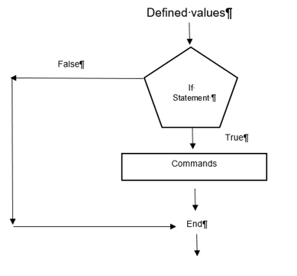


HOW TO?
Example 6-1
We want to determine the workers’ pay with the number of hours they worked, but the condition is that the statement must only show the answer if it is above a certain value.
The program calculates the hourly wage of the worker. The if-statement then checks if it is above the 40 hours. If it is, the next line is executed. If not, then the command ends. The other part of the code is not executed.

Solution: Pseudocode
Step 1:
We want to know how the working wage increases by a new value after 40 hours. Because we want an input as if it is a calculator, we need to make use of an input function.

Step 2:
- We need to understand ‘input function’
- We need to understand how to get and output function e.g. fprintf
- Our knowns:
- t = time
- h = wage rate
- standard pay equation
- New pay equation based on condition

Step 3:
- Wages are a product of time and hours worked
- Time = t = input function for hours
- Wages = h = hourly wage input function
- The pay = t x h
- If the time worked is greater than 40 hours (t>40)
- Then a new equation ah to be used to calculate the new pay.
- The new equation is here.
- If the hours, t < 40 hours, then end the if statement and revert to the original equation to calculate the pay.

Steps 4 and 5:
clc, clear % do not use close all here. It will not show the printed part below

t = input('Please enter the number of hours worked');
h = input('Please enter the hourly wage in $');

Pay = t* h;

if t > 40 %

Pay = Pay + (t-40) * 0.5 * h;

end

fprintf('The workers pay is $ %5.2f',Pay)

% what the code ultimately does is, that it will print the value of Pay,
% but if the t is greater than 40, it needs to use the value for Pay in the
% if statement instead.

>> Please enter the number of hours worked 35
>> Please enter the hourly wage in $8
>> The workers pay is $ 280.00>>

>> Please enter the number of hours worked 50
>> Please enter the hourly wage in $10
>> The workers pay is $ 550.00>>

The use of pseudocode requires you to understand the problem as a whole before it can be applied. It will initially be trial and error before you get the hang of how to solve the problems.

3.4 The If-else-End Statement
With this statement, there are two sets/groups of commands that have conditions. This statement has two conditional statements, ‘if’ and ‘else-if’. The first line is an ‘if’ statement with conditional expressions. If the conditional expression is true, the programme will execute ‘eh’ command between the ‘if’ and ‘else-if’ statement.

If the conditionals statement is false, the programme skips to the ‘else-if’ statements. If that set of conditional statements commands are true, then the programme will except those commands. If that set of conditional statements are not accepted, it is false and executes the commands in group 3.


HOW TO?
Example 6-2
Analyse the following example: A water tank in a water tower has the geometry as shown in figure Figure 6-1. Inside the tank there is a float that indicates the water level. We have to create a programme that determines the volume of water with respect to its height. The program requests the user to enter an input value for h (height) in m, and then displays the output.

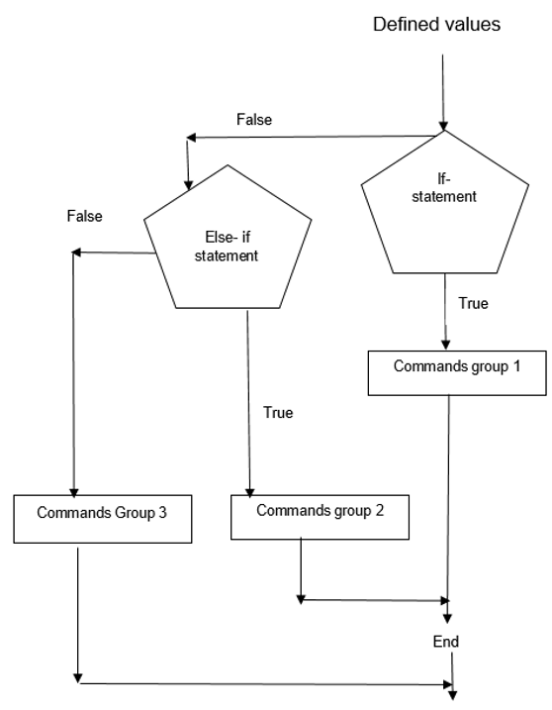
Figure 6-1: Water Tank
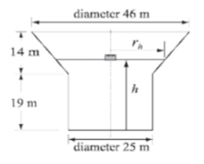
Diameter: 46 m

h
$$r_{h}$$
14 m

19 m

Diameter: 25 m

Figure 6-2: Water Tank in Water Tower

Solution
We first need to take a closer look at the shape of the water tower. If it was a simple cylinder, it would be straight forward to determine the volume of water with respect to the height. But in this case, its combination of a cylinder and cone shape tower.

For 0 ≤ h ≤ 19 m, the volume of water would be given as a volume of the cylinder, thus:
V= π 〖 x 12.5 〗^2 h

For 19 ̴≤ h ≤ 33m

V=π 〖12.5〗^2 x 19+ 1/3 π ( h-19)( 〖12.5〗^2+12.5 r_h+〖r_h〗^2

3.5 Pseudocode
Step 1: Understand the problem:
- We want the volume of water in the tank, with respect to the height.

Step 2: Break up the problem:
- Define the variables.
- Define the knows and unknowns
- What will be the inputs?
- Determine the boundary values

Step 3: Write it out in pseudocode:
- Create the input function for h
- Create conditions for the heights:
  - ‘h’ cannot be greater than 33 m, otherwise its undefined since the tower has a max height of 33m.
  - ‘h’ cannot be less than 0m too.
  - When h < than 19m, a certain equation is used.
  - Then create a statement that if it’s between 19m and 33 m, use another formula.

Step 4: Write it out in actual code:
clc, clear

% This program will calculate the height of water in the water tower with
% respect to its height.

h = input('Please enter the height of the float in meters');

if h > 33
disp('UNDEFINED VALUE!! The height cannot be > 33m');

elseif h < 0
disp('UNDEFINED VALUE!! The height cannot be less than 0');

elseif h <= 19
v = pi * 12.5 ^ 2 * h;

fprintf('The volume of the water is %7.3f cubic meters .\n',v);

else
rh = 12.5 +10.5 * (h-19)/14;
v = pi * (12.5 ^2) *19 + (pi/3) *(h-19) * (12.5 ^2 +12.5 * rh +rh ^2);

fprintf('The volume of the water is %7.3f cubic meters .\n',v);

end

Step 5: Test the code
>> Please enter the height of the float in meters20
>> The volume of the water is 9847.519 cubic meters.

>> Please enter the height of the float in meters17
>> The volume of the water is 8344.855 cubic meters

The input commands were answered in the command window when the programme ran.

3.6 The Switch-case Statement
The objective to the switch case statement is to choose one group of commands for the execution out of several possible groups. In most cases it is a variable with an assigned scalar or string. Switch cases offer a more efficient alternative to if else statements. Note that switch case cannot be used relational operators with switch cases, and if we want to use relational operators, w=it is best advised to use if-else statements.

How does the switch case statement work? As the term states, it switches between different commands or different options until the correct one is found. Switch expressions can be scalar or strings


HOW TO?
Example 6-3 – Converting units of Energy
We need to write a program that converts energy (work) given in unit of either joule, ft-lb, Cal or eV to the equivalent quantity in different units specific by the user. The program asks the user to enter the quantity of energy, its current units and the desired units. The output is the quantity of the energy in new units.

The conversion factors are: 1J = 0.738ft-lb= 0.239cal = 6.24 x 10 18 eV.

Us the program to:
- Convert 150 J to ft-lb
- Convert 2 800 cal to J
- Convert 2.7 eV to cal

clc

Ein = input ('Enter the value of the energy to be converted:');
EinUnits = input('Enter the current units (J, ft-lb, cal or eV): ','s');
EoutUnits=input('Enter the new units (J, ft-lb,cal, or eV ): ','s');

error = 0
switch EinUnits
case 'J'
EJ =Ein;

case 'ft-lb'
EJ=Ein/0.738;

case 'cal'
EJ =Ein/0.239;

case 'eV'

EJ = Ein/6.24e18;
otherwise
error =1;
end

switch EoutUnits

case'J'

Eout =EJ;

case 'ft-lb'
Eout =EJ * 0.738;

case'cal'
Eout =EJ * 0.239;

case 'eV'
Eout =EJ * 6.24e18;

Otherwise
error=1;

end

if error
disp('ERROR current or new units are typed incorrectly.')

else

fprintf('E = %g %s', Eout, EoutUnits)

end

>>Enter the value of the energy to be converted: 5000
>>Enter the current units (J, ft-lb, cal or eV): J
>>Enter the new units (J, ft-lb,cal, or eV ): cal

>>error = 0

>> E = 1195 cal>>

3.7 For-end Loops
For-end loops, the execution of these commands are repeated as set number of times.

for k = f: s:t
(a group of MATLAB commands)
end
- k: loop index variable
- f: The value of k in the first pass
- s: The increment in k after each pass
- t: The value of k in the last pass.


HOW TO?
Example 6-4 – How does MATLAB read these instructions?
Use a for-end loop in a script file to calculate the sum of the first n terms of the series:
$$\sum_{k=1}^{n}{\frac{{(-1)}^{k}k}{2^{k}}}$$
Execute the script file for n =4 and n=20

Solution: Pseudocode
Step 1: Understand the problem:
Lets’ try to understand the problem first. When we do summations and series, we know that we must lop through numbers to get an answer. So, the for-end loop is a good tool to use,

Step 2: Break up the problem:
- Define the variables and input values.
- Define the knowns and unknowns
- Determine starting point, S= 0

Step 3: Write it out in pseudocode:
- Define the input value, n.
- Define the starting point, S = 0Open the for loop for certain conditions
- Write the summation
- End the for loop
- Print the answer

Step 4: Write it out in actual code and test it:
clc, clear
n = input ('Enter the number of terms');
S = 0;

for k = 1: n
S= S + (-1) ^k*k/2^k;
end
fprintf('The sum of the series : %f', S)

>> Enter the number of terms 10
>> The sum of the series: -0.218750>>

Enter the number of terms 20
The sum of the series: -0.222216>>

3.8 While-end Loops
While-end loops are used when looping is needed but the number of passes is unknown. The looping process continues if the conditions is satisfied, hence the term ‘while’.

The structure is as follows:

While conditional expression

(a group of MATLAB commands)
end

The first line contains the conditions. As the program runs, it checks the conditional expression. If it is false (0), then it skips to the ends statement and continues running the programme. If it is true (1), MATLAB will execute the commands in between the while and end loop. It will then jump back to check the expression until the expression is false.

We need to keep a few things in mind when creating while loops:
- The conditional expression in the while commands must include at least one variable.
- It must have assigned values for the first time.
- At least one of the variables in the expression must be assigned a new value that’s between while and end.
- The coder needs to ensure that the variables in the conditional expression and will eventually be assigned values that make it false. If not, the loop will continue indefinitely. If you notice this, use the break command inside the loop or ctrl + C in the command window


HOW TO?
Example 6-5 – We will skip the pseudocode for this one since the example is quite simple.

clear , clc

x = 1 % the starting point is 1; this needs to be defined first while x <= 15 % the while loops needs a condition with a variable

x = 2*x % the loop executes until the condition of less than and equal to 15 is no longer true
end

x = 1
x = 2
x = 4
x = 8
x = 16

3.9 Nested Loops and Nested Conditional Statements
Loops and conditional statements can be nested inside other loops or conditional statements. There is no limit to the number of loops are conditional statements that are inside each other. However, it should be noted that for all these conditional statements and loops, each one should have its own corresponding end statement.

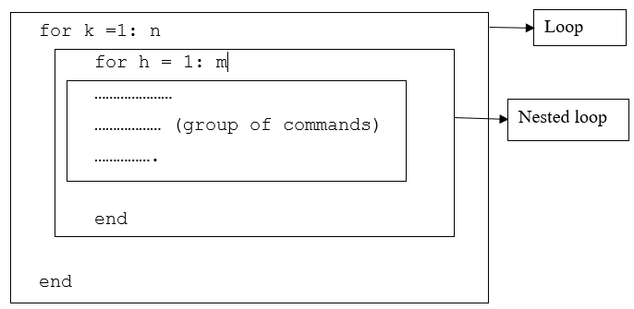
Figure 6-3: Nested Loops and Conditional Statements

How is the nested loop is executed? The outside loop is read for those conditions starting at value, the next loop that is read, is the nested loop for those values that make the outside loop true. One that is true will execute the commands inside the nested loop until it is no longer true. It will then revert back to the outside loop for all the values that made the inside loop true, until it is false and then the commands end.

It’s advisable to use pseudocode and flowcharts in to understand nested loops. When considering nested loops, it’s important to have the main concept in the innermost loop that is true and then work to the outward conditions.


HOW TO?
Example 6-6 – Creating a matrix with a loop
We want to create a script file that creates a n x m matrix with elements that have the following values. The value of each element in the first row is the number of the column. The value of each element in the first row is the number of the row. the rest of the elements have a value equal to the sum of the elements above it and to the left. Because we are creating it from scratch, we have to create input functions for n and m.

Solution: Pseudocode

Step 1: Understand the problem:
We want to create a n x m matrix. We need to understand the numbering positions of each element. Sometimes it is easier to wrote the flow chart on paper before coding.

Step 2: Break up the problem:
- Define the input values for n
- Define the input values for m
- Determine how the matrix going to be created using principles of created matrices of any size
- Determine how we will loop through each element
- Let’s look at a simple 3 x 3 matrix below:
  - First create matrix of a known size, with the values and element names
  - Determine the values that are supposed to be there and determine the equations to get those values.

Formula =
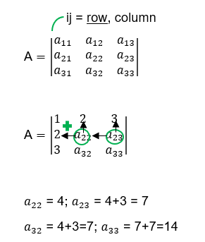
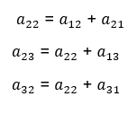

- How will we put this formula in the loop?
  - We first want to define the first row and column
  - Then we work from there in each direction simultaneously.

Step 3: Write it out in pseudocode
- Create input values for n
- Create input values for m
- Create a matrix of any size
- We must work with the inside and outside at the same time using loop principles.
Step 4: Write it out in actual code and test it
clc, clear;

n = input('Enter the number of rows');
m = input('Enter the number of columns');

A = []; % here we are creating a matrix of unknown size and defining the matrix

for k = 1:n % for column row k, starts at 1 and ends at n
for h = 1: m % for column h, starts at 1 and ends at m
if k ==1 % if the value for k is 1

A(k, h) =h ;% then let that value for that element be h. If not, then move on
elseif h ==1 % if the value for h is 1, then let it have that value of k. If not then move on

A(k,h) = k;

else % if none of the above is true then complete the below until all the elements are completed. Once it is no longer tru9all elements used u)
% end the code and end the loop.
A(k,h) = A(k, h-1) +A( k-1,h);
end
end
end
A

>> Enter the number of rows 4
>> Enter the number of columns 4

>>A = 1 2 3 4
2 4 7 11
3 7 14 25
4 11 25 50

4. Data Visualisation

4.1 Two-D Plots
We can graphically represent our data and place them in reports and documents for when we need to express our ideas to people outside of the engineering space, or people that do not understand our mathematic calculation. It is also a good option since some people might be better at understanding graphical information over words or numbers. Plotting is a good way to gauge if the value we inserted in the programme makes sense.

4.2 The Plot Command
We make use of the plot command to illustrate 2D illustrations. Both x and y arguments are vectors and need to be written as arrays When we create a plot command, a figure is displayed in the figure window. The x and y values correspond with the x and y axis we us in mathematics.
plot (x,y)

The above is a basic plot function. Below we have an expanded plot function if we want to edit some of the features and characteristics.
plot(x,y ,‘line specifiers’, PropertyName’, ‘PropertyValue’)


READ Additional Resources

Refer to the following resource in the Student Portal.
Read: Prescribed Textbook: Gilat, A. (2012). MATLAB: An Introduction with Applications (6th ed.). Wiley. pages 135-137 – exhaustive list of the built in functions.


HOW TO
Example 7-1 – The Plot Command

x = [1.1 1.8 3.2 5.5 7 7.5 8 10] ;
y = [2 6.5 7 7 5.5 4 6 8];
plot(x,y)

Solution

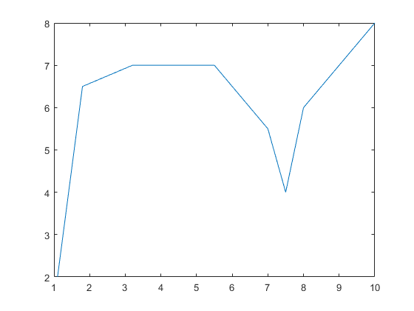
Figure 7-1: Image Applying the Formula

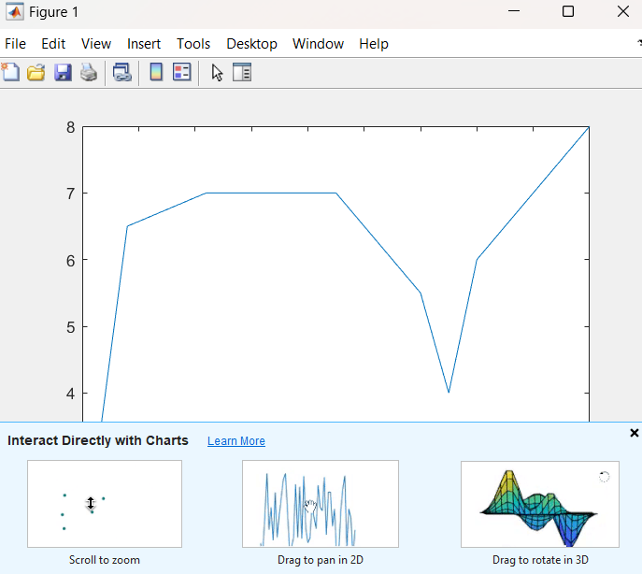
Figure 7-2: Screenshot of the Figure Window

4.3 Using the Provided Data
When plotting data that has been provided, the data should preferably be arranged in a suitable table before it is used. The following table contains sales data of a company from 1990 to 1998.

Year | 1990 | 1991 | 1992 | 1993 | 1994 | 1995 | 1996 | 1997 | 1998
Sales (millions) | 8 | 7 | 5 | 11 | 24 | 30 | 21 | 15 | 22
Table 7-1: The Amount of Sales a particular Company made each Year

We can either import this data (covered later on) or we can type it out.
clc, clear
yr = 1990:1:1998;
sale = [8 7 5 11 24 30 21 15 22 ];
plot(yr, sale, '--r*', 'LineWidth', 1 ,'markersize', 12)

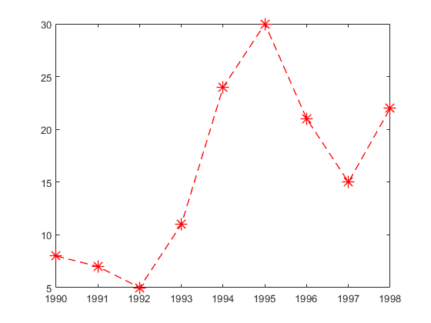
Figure 7-3: Plot displaying the Programme above.

4.4 Plotting a Function
Plotting functions are quite easy. We need to create and array for the values of x, and then a function for the vector of y. The same way a function is written out.


HOW TO?
Example 7-2

clc
x = -2:0.01:4;
y = 3.5 .^(-0.5*x).* cos (6*x);
plot(x, y)

Solution

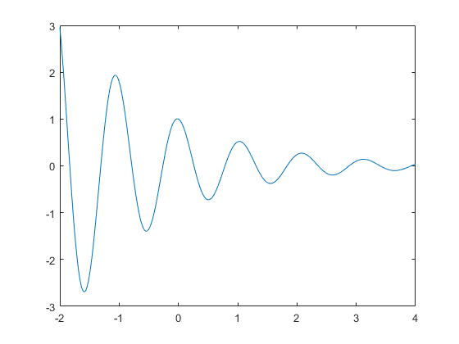
Figure 7-4: Plot displaying the Program in Example 7-2

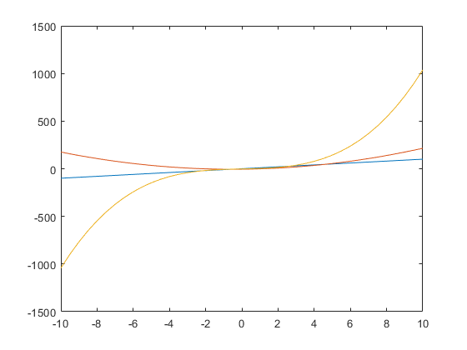
Figure 7-5: Displays the Programme in Example 7-3

4.5 Superimposing Multiple Plots
We can place multiple graphs on one plot. (x, y), (u, v) and (t,h). the vectors of each pair must be the same length. We do not need to change the colours as MATLAB already does this for us. But if we would like specific styles and colours, we can use the built-in functions mentioned that the beginning of this chapter.
plot(x,y ,u,v,t,h)


HOW TO?
Example 7-3 – Plotting three graphs

$$y1=3+x$$
$$y2={2x}^{2}+2x-5$$
$$y3=x^{3}+4x-2$$

x = -10:0.5:10;
y1 = 0.5+10.*x; % take not of the .* and the .^. This dot product is need for multiplication and powerd of matrices. So any time a product or a power is used, the dot has to come before the symbol.
y2 = 2.*x.^2 +2.*x -5;
y3 = x.^3 + 4.*x -2;

plot(x,y1,x,y2,x,y3)

The study guide currently only makes use of the most basic plots.


READ Additional Resources

Refer to the following resource in the Student Portal.
Read: Prescribed Textbook: Gilat, A. (2012). MATLAB: An Introduction with Applications (6th ed.). Wiley. Chapter 5 – Plots and examples.

5. Database Storage and Retrieval

5.1 Managing Script Files and Data
A script file is a list of commands executed in MATLAB a and is called a programme; thus it is saved in a file.

When a script file is run, it executes the command. We need to know how to save these files, retrieve data and exchange it with other applications. For now, we will focus more on storage and retrieving data.

We will cover he following commands:
- Input Commands
- Disp Command
- Fprintf Command
- Importing and Exporting Data

5.2 Input Commands
Variable_name = input (‘string with a message that is displayed in the command window’)

This set of commands requires you to input a value or variable in the command window, pertaining to the defined variable

game1 = input('Please enter the game 1 score');
game2 = input('Please enter the game 2 score');
game3 = input('Please enter the game 3 score');
Avg_game= (game1+ game2+ game3)/3;

Avg_game
>> Please enter the game 1 score 100
>> Please enter the game 2 score 200
>> Please enter the game 3 score 269

>> Avg_game = 189.6667

Variable_name = input (‘prompt message’, ‘s’)

In the command above, we can assign string to a variable. The ‘s’ inside the commanded defined the characters that will be entered as string

currency = input('Please enter the currency ($, R, Dinar ): ', 's');

>> Please enter the currency ($, R, Dinar ): $

5.3 Disp Command

disp(name of variable )
or
disp(‘ text as string’)

The disp command is used to display content, either as array and vectors, or as a string or elements of a variable without displaying the name of the variable. It is mostly used to display messages if certain variables are not true in loops.

5.4 Fprintf Command
The print command is multidimensional. We use it to display some text without the variable name attached to it.
fprintf (‘text type as a string’)

There are other features we can add to the print command. The \n is called the escape character. It controls the display. The print command when display is continuing, even if there are other commands in-between, it will display all the print commands in a s sequence.

Another feature of the print command is the fact that we can display a mix of text and numerical data:
fprintf (‘text type as string’ %-5,2f additional text’, variable_name)

Print command breakdown:
- % sign: marks the spot where the number is inserted in the text
- -5.2f: are formatting elements for the decimal places of the number
- Variable_name – the name of the variable displayed.

The formatting elements are: -5.2f:
- ‘- ‘: flag(optional)
- 5.2: Field width and precision
- f: conversion character


READ Additional Resources

Refer to the following resource in the Student Portal.
Read: Prescribed Textbook: Gilat, A. (2012). MATLAB: An Introduction with Applications (6th ed.). Wiley. page 105.

game1 = input('Please enter the game 1 score');
game2 = input('Please enter the game 2 score');
game3 = input('Please enter the game 3 score');

Avg_game= (game1+ game2+ game3)/3;

fprintf(' An average of %f goals were scored', Avg_game)

>>Please enter the game 1 score 100
>>Please enter the game 2 score 250
>>Please enter the game 3 score 325
>>An average of 225.000000 goals were scored

It is possible to enter more than one number value with the print command:
fprintf (‘text…’ %f..%f..%f’, variable1, variable2, variable3)

5.5 Importing and Exporting Data
Importing data from an Excel file using the xlsread command.

Variable_name = xlsread(‘filename’)

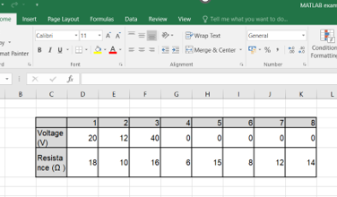
Figure 8-1: Displays the table in Excel

% note: in order to retrieve the data, the Excel file and the current
% programme has to be saved in the same directory.
data = xlsread('MATLAB examples');
data

data =
1 2 3 4 5 6 7 8
20 12 40 0 0 0 0 0
18 10 16 6 15 8 12 14

- The file name has to be typed as a string
- The data from excel is assigned as an array to variable.
- If Excel has more than one sheet, the data will be imported form the first sheet.
- If you would like to import data from specific sheet, use the command below:
Variable_name = xlsread(‘filename’, ‘sheet_name’)
- We can also select a portion of the data we want to use in our programme:
Variable_name = xlsread(‘filename’, ‘sheet_name’, ‘range’)
- We can also export data from MATLAB to an excel spread sheet by means of the following command:
xlswrite(‘filename’, variable_name)
- The same principles follow for exporting as it does for importing.
- The file name is the name of the file the data will be exported to. If it does not exist, a new file will be created.

